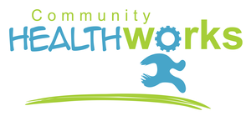

**Rotherham**

**Edward Dunn Memorial Hall, Maltby. S66 7NQ**

**Rawmarsh Children’s Centre, Rawmarsh. S62 6AD**

**The Unity Centre, St Leonards Road, Rotherham. S65 1PD**

**Do you want to feel better?**

**Look better? Be healthier?**

***We can help you...***

•  ***Lose weight***

• ***Reduce medication***

• ***Be more active***

• ***Improve your balance & co - ordination***

• ***Reduce your alcohol intake***

• ***Stop smoking***

• ***Help you feel better about yourself***

• ***Improve your confidence***

• ***Prepare for education, training or employment***

***Our programme will show you how easy it is to feel better than you’ve ever felt in just 8 weeks!***

**\*\*Free subject to eligibility\*\***

 

For more information call Woodthorpe Development Trust on 01142654165 /07958424638

or email healthworks@woodthorpedt.co.uk or lee or shaun@woodthorpedt.co.uk



4